A000-US-OH-Erie County-Birdstone-Cooper-1200 CE

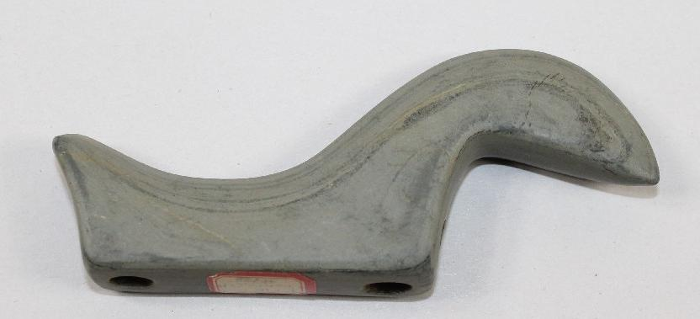

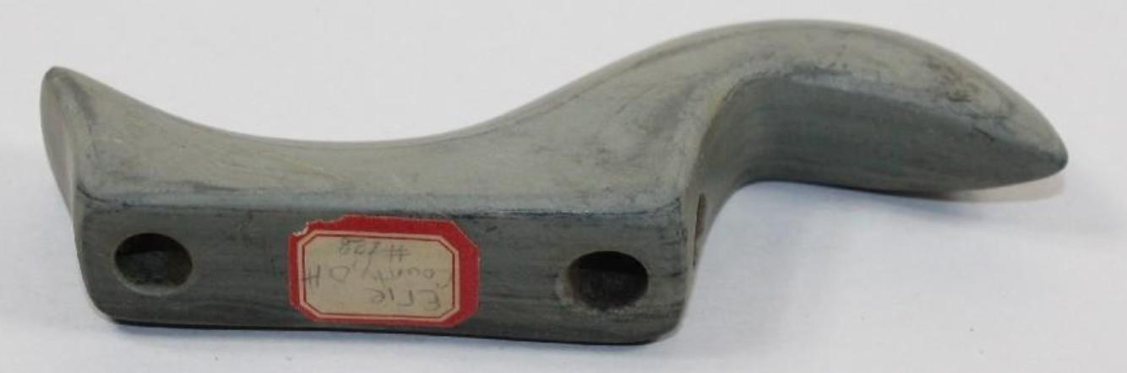

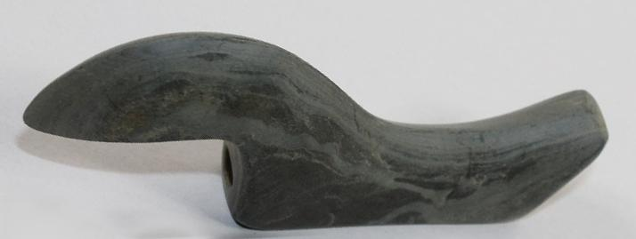

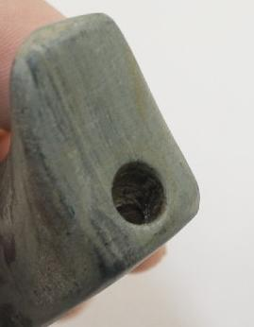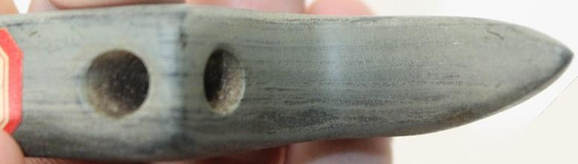

US-OH-Erie County-Birdstone-Cooper-1200 CE

Case no.: 11

Accession Number:

Formal Label: US-OH-Erie County-Birdstone-Cooper-1200 CE

**Display Description:**

"The probability--is that these bird-stones were used or worn by the men rather than by the women, and Cushing's theory that they were attached to a plate and fixed to the hair is plausible." The underside (of birdstones) is flat or slightly concave, and there are two perforations at the extremities of the base intended to serve in attaching the figure to the surface of some object, as a tablet, a pipe stem, a flute, or a staff or baton, or some part of the costume, or to the hair”-- Frederick Webb Hodge, 1919. "Bird-Stones," *Handbook of American Indians North of Mexico*, part 1, Washington, DC: Smithsonian, p. 148.

"It may reasonably be concluded from the uniform shape of these (birdstones) articles, and from their apparent unfitness as implements, as also from the wide range of their occurrence, that they were invested with a conventional significance as insignia or badges of distinction or as amulets"---E. G. Squier and E. H. Davis. 1848. "Ornaments Of Stone, Bone, Etc.," *Ancient Monuments Of The Mississippi Valley*, p. 239.

**LC Classification:**

Date or Time Horizon:

Geographical Area:

**Map:**

**GPS coordinates:**

Cultural Affiliation:

Media:

Dimensions: 4-1/2" long by 1-7/8" tall.

Weight:

Condition:

Provenance: It was found in Erie County, Ohio. It is made out of Banded Slate. It is 4-1/2" long by 1-7/8" tall. It comes with a Thomas E. Shenk COA. It also comes with a Grade 9.5 Jeff Baker COA.

[Thomas E. Shenk | Department of Molecular Biology](https://molbio.princeton.edu/people/thomas-e-shenk)

[Department of Molecular Biology - Princeton University](https://molbio.princeton.edu/people/thomas-e-shenk)



[tshenk@princeton.edu](mailto:tshenk@princeton.edu)

609-258-5992

609-258-1704

Thomas Laboratory, 203

[Shenk Lab](https://molbio.princeton.edu/research/labs/shenk-lab)

Discussion:

|  |  |
| --- | --- |
| **ILLUSTRATION FROM 1912 SMITHSONIAN PUBLICATION BIRDSTONES EASTERN UNITED STATES LATE ARCHAIC**   |  | | --- | | **These six drawings of birdstones illustrate several of the different "main" forms. The two birdstones at top represent one of the most elaborate types. Both have popeyes but one has feet and the other does not. The next two represent the most common style. One has a short body and the other is the elongated form. Notice also that one has a mouth and the other does not. One survey of 1,000 birdstones showed that 10.7% had incised mouths. The two bottom examples are the simplest forms of birdstones. The example on the left still has a recognizable head and tail but the example on the right only has two raised ridges to represent the head and tail. The one on the right is also referred to as a bar amulet.     Birdstones have been found in an endless variety of form. Dr. Thomas Wilson is quoted in Moorhead 1917: "The United States National Museum posses many of these specimens (birdstones). While they bear a greater resemblance to birds than anything else , yet scarcely any two of them are alike and they change in form through the whole gamut until it is difficult to determine whether it is a bird, a lizard, or a turtle, and finally the series ends in a straight bar without pretense of presenting any animal."** | |
| **Birdstones date from the Late Archaic to the Early Woodland periods. Only a handful of them have been found during the excavation of burials. Two bar style birdstones are reported to have been found in the head area of a single adult on the Baker II Late Archaic site in Sandusky  County, Ohio. The Baker II site dates to the terminal Late Archaic period at 2,820 years ago. A popeyed style birdstone is also reported to have been found during the excavation of an Early Woodland burial containing three individuals on the Danbury site in northern Ohio dating to around 2,500 years ago. Bust type birdstones have also been reported from Early Woodland Adena mounds. Birdstones are also associated with Glacial Kame sites.** |

**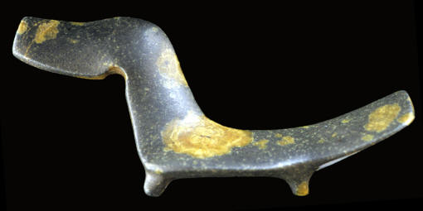  
FANTAIL BIRDSTONE**CHITTENDEN COUNTY, VERMONT

**This fantail birdstone was found in 1846 by S. H. Baker in Chittenden County one mile north of Burlington, Vermont. This is another of the more rare and beautiful forms of birdstones. It was made from a colorful stone and its complex style includes "feet," a large rectangular head, and wide tail. It's also drilled through both "feet."  This birdstone is made of porphyry and measures 4 1/2 inches (11.4 cm) long.**

**References:**

**1848**, Squier, E. G. & Davis, E. H., "Ornaments Of Stone, Bone, Etc.," Ancient Monuments Of The Mississippi Valley, p. 239. **1896**, Wilson, Thomas, "Prehistoric Art; Or The Origin Of Art As Manifested In The Works Of Prehistoric Man," Report Of The U.S. National Museum, p. 450. **1898**, Williams, Frederick H. M.D., "Amulets," The American Archaeologist, Vol. 2, No. 8, pp. 200-202. **1912**, Hodge, Frederick Webb, "Bird-Stones," Handbook Of American Indians North Of Mexico, pp. 148-149. **1917**, Moorhead, Warren K., "Stone Ornaments Used By Indians In The United States And Canada," p. 88. **1959**, Townsend, Earl C., "Birdstones Of The North American Indian," pp. 3**.  
1975**, Tiell, William W., "The Incised Mouth Birdstone," Ohio Archaeologist, Vol. 25, No. 3, pp. 20 -21. **1979**, Fincham, Glenval, "A Novel Explanation Of The Origin And Development Of The Birdstone," Ohio Archaeologist, Vo. 29, No. 4, p p. 14-15. **1984**, Illustration, "Central States Archaeological Journal, Vol. 31, No. 3" p. 135. **1993**, Zakucia, John A., "The Birdstone, An Enigma Of The Prehistoric Past," Ohio Archaeologist, Vol. 43, No. 1, p. 27. **2003**, Skrivanie, Oliver T., "The Fab Five," Prehistoric American, Vol.37, No. 2, p. 4. **2004**, Power, Susan C., "Early Art Of The Southeastern Indians Feathered Serpents & Winged Beings," p. 28. **2006**, Werness, Hope B., "Bird," Animal Symbolism In Art, p. 44.  
**Personal Communication**, Dennis Vesper.  
**Clem Caldwell Collection Pictures**, Dennis Vesper.

**APPENDIX:**

[OHIO BANDED SLATE BIRDSTONE W/DUAL PAPERS](http://www.ebay.com/itm/391428024643)

|  |  |  |
| --- | --- | --- |
| Item price |  | $556.00 |
| Quantity |  | 1 |
| Item number |  | 391428024643 |
| Shipping service |  | USPS Priority Mail |

## Valued at $6,000.00